Executive Committee Members
Tim Fahey, (Co-Chair)
Kyu-Jung Whang, (Co-Chair)

Lauren Chambliss
Mary-Lynn Cummings
Michael Hoffmann
Gary Stewart
Lesley Yorke
Lisa James
Bert Bland

Dan Roth (Committee Manager)

Aug 30th, 2014

Dear President Skorton,

Since the 2013 Campus Sustainability Strategic Plan, Cornell’s sustainability efforts have made great progress and were acknowledged last year by the Sierra Club ranking as the #5 greenest school in the United States. Based on data from our annual performance reporting to the Sustainability Tracking, Assessment, and Rating System (STARS), Cornell’s sustainability commitment is having a demonstrable positive impact. During this period the Climate Action Plan was thoroughly updated and a report on accelerating implementation of the Climate Action Plan was completed. While these successes are exciting, there is a long road ahead for Cornell to become truly sustainable in campus operations and culture.

As requested in the original charge of the President’s Sustainable Campus Committee (PSCC) the committee has prepared a 2014 Annual Report of the accomplishments to date and goals for the year ahead. The report includes several sections:

  - Status of 2013 PSCC goals and additional highlights
  - Snapshot of key indicators from STARS data
  - Senior Survey results to sustainability questions
  - Report from the PSCC Advisory Committee
  - FY2015 PSCC goals
  - PSCC FY2015 calendar of key events

2013 PSCC Goals | Status | Outcome
Update the Climate Action Plan | Complete | Update was released in May and provided framework for acceleration report
Pilot a Sustainability Engagement Campaign | Complete | College of Engineering pilot complete, Human Ecology campaign begins Fall 2014
Implementation of a broad social media strategy | Complete | Facebook and Twitter use has increased approximately 65% since 2011
Continuous improvement through sustainability performance reporting | Ongoing | 3rd STARS Gold certification complete.  New goal is Platinum certification.
Stimulate multidisciplinary sustainability research | Ongoing | Atkinson Center provided $1.4M in seed funding in FY14, a 50% increase
Advancing leadership development programs | Ongoing | Management training offered twice and college Green Ambassadors launched
Engage in partnerships to promote sustainability outside Cornell | Ongoing | Ivy Plus Sustainability Consortium formally launched

Additional PSCC Highlights | Details
Annual Campus Sustainability Summit | Hosted by the Statler Hotel and featuring keynotes from President Skorton and VP Mangum, 120 participants attended
Partners in Sustainability Award | Over 20 students and staff were nominated. Staff winners: Joan Manheim and Erin Moore. Student winners: Becca Macies and Celine Johnson. Community winner: Building Bridges Initiative.
Climate Action Plan Acceleration Report | Faculty from 4 colleges partnered with members of the PSCC to develop a plan to accelerate the Climate Action Plan
Launched PSCC Advisory Committee | The Advisory Committee was launched with associate deans from 4 colleges, students, and leaders from SAS, HR, and DFA.
New Skills for Success | Sustainability was established as an overarching principle for all staff, and the stewardship skill added sustainability language that will inform annual performance management processes.
First solar farm | Cornell’s first large scale, 2 megawatt solar system was built near the Tompkins County airport, and will begin producing in September
Carbon reduction partnership with Chevrolet | Cornell partnered with Chevrolet to monetize past carbon reductions and support additional renewable energy projects on campus.

Key STARS Sustainability Indicators

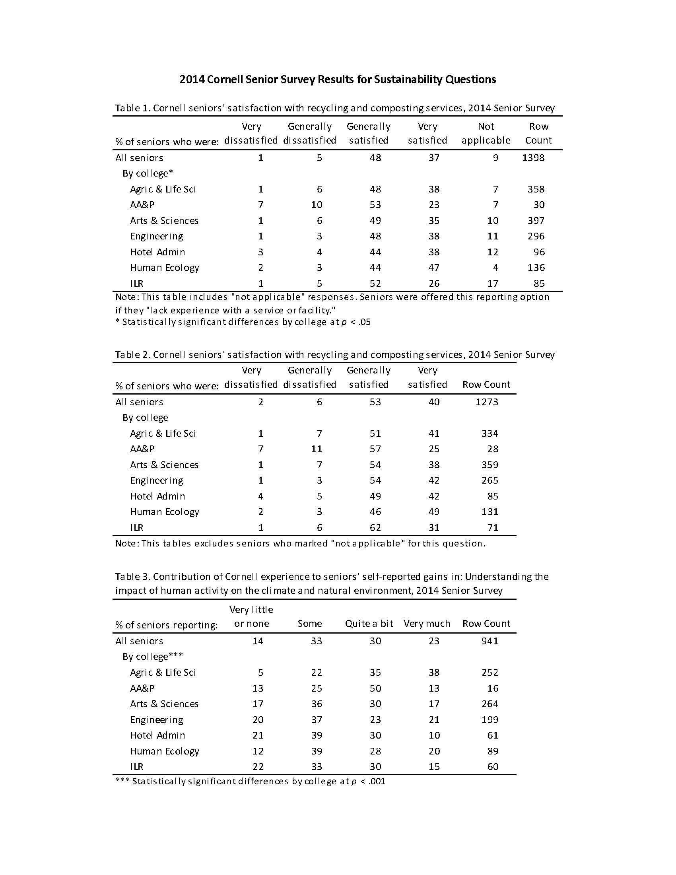

FY2015 PSCC Goals | Indicators of success
- Advance the recommendations of the Climate Neutrality Acceleration Working Group | - Campus Forum on climate action has over 300 participants  - Funding plan for one year milestones is developed  - Board passes new energy conservation policies
- Increase student sustainability literacy and collect data to measure impact | - 90 % of freshmen participate in sustainability training and survey  - 3 sustainability questions are added to the Pulse survey
- Implement Green Office and Green Lab Certifications university-wide | - 10% of campus offices are certified
- Support integration of sustainability into annual performance management processes | - New guidelines for performance management are developed and released  - HR and FS develop sustainability tools for managers
- Host annual sustainability summit | - Over 180 participants attend November summit
- Manage the annual Cornell University Partners in Sustainability Award | - Nomination committee receives more than 15 nominations for each category
- Strengthen PSCC governance structure | - Focus Team leaders report increased support from Executive Committee  - Executive and Advisory Committee members meet together 4 times

PSCC Team | FY ‘15 Team Goals
BUILDINGS | - Support the planning, design and development of the first Net Zero Energy major renovation at Rice Hall.
CLIMATE | - Advance the Travel offset policy recommendation with key decision makers/stakeholders and promoted  - Submit bi-annual greenhouse gas reports to American College and University Presidents Climate Commitment  - Seek external funding for afforestation and forest management CAP actions.  - Advocate for more sustainable forest management/preservation on CU investment/partnership holdings for carbon sequestration purposes.  - Evaluate the value and need for a more coordinated CU approach to adaptation planning, and if so, what value would be added.
ENERGY | - Support university efforts to diversify energy portfolio with solar PPA’s at Snyder Rd, Harford and other off campus locations.
FOOD | - Increase regional food purchasing:  - To establish University policies that support a sustainable food system:  - Minimize waste at Cornell Dining units.  - Community Education
PEOPLE | - Work with at least one college/unit Toward New Destinations team to develop a goal connecting diversity and sustainability  - Measures of the carbon impact savings for participants in the ILR/HRSS remote work study participants as well as some other relevant employee engagement/ sustainability measures.  - Employee Onboarding Center sustainability materials developed and offered in OBC b  - Expand Green Ambassadors Program to other colleges/units, especially Human Ecology  - One pilot training on campus of "PeopleFuel",  Implement at least one campus program focused on encouraging employees sustainable practices in employee homes.
PURCHASING | - Support procurement of carbon offsets  - Encourage and market the benefits of purchasing locally, and highlight EPEAT, ENERGY STAR, and Green Seal certified products in all areas for which such ratings exist  - Include a section devoted to sustainable accomplishments in the Procurement Services quarterly newsletter and highlight sustainable vendors in each issue.  - Expand the number of participating suppliers by 20-25%.  - Review inbound logistics, and implement a program that assists small and local businesses with freight consolidation.  - Increase percentage of ecologo and green seal janitorial products
WASTE | - Engage stakeholders in development of a university waste policy  - Expand residential composting pilot program
WATER | - Continue to support TBTT initiatives and complete tasks on our tracker  - Participate in Watershed Protection initiatives  - Support energy efficient and water conservation projects  - Storm-water regulatory and infrastructure involvement  Continue investigation into water losses on campus

 | Aug | Sept | Oct | Nov | Dec |  | Jan | Feb | Mar | Apr | May | Jun | Jul
Full PSCC Meetings |  |  |  | Summit |  |  |  |  |  | Mini-Summit
Individual Focus Team Meetings* | X | X | X | X | X |  | X | X | X | X | X | X | X
Focus Team Networking Lunches | 1 ½ hrs |  |  |  |  |  |  | 1 ½ hrs
Focus Team Strategic Planning Meetings |  |  | 1 ½ hrs |  |  |  |  |  |  |  | 1 ½ hrs
Notable Events |  |  | TCAM & Campus Sust Day |  |  |  |  |  |  | Earth Day
Deliverables |  |  |  | Goal Setting (annual)
 |  | STARS Data Collection (annual) |  |  |  | CAP or GHG update (every other year);  Sustainability Plan (5-10 yrs) next in 2015 |  |  |  |  | Web Updates

