2019

Campus Sustainability

Progress Report

Cornell University

sustainablecampus.cornell.edu
@sustainablecornell

Letter to the President

2019 Campus Sustainability Report
Dear Provost Kotlikoff,

Cornell University remains the leading Ivy university for sustainability!

Our campus has seen particular growth this year in engagement programs among students, faculty, and staff. We continue to invest in local, regional, and state-level sustainability coalitions and learning partnerships, and we remain an innovative living laboratory campus, with dozens of projects utilizing our campus operations and systems to stimulate sustainability solutions.

Notable highlights this year include:
- 8th year of AASHE STARS Gold Rating
- #7 in the Princeton Review’s Top Green Schools
- 36% reduction to our carbon footprint to date
- 75 Green Offices and 15 Green Labs are certified across campus
- Newly redesigned Sustainable Campus website features 100s of pages of refreshed content in a fully WCAG 2.0 Accessibility compliant design
- Dining Services successfully piloted a reduction in single-use plastic for grab and go food items which will save 2,100lbs of plastic per location, per year
- New comprehensive waste signage was designed and is being implemented for a more cohesive & easy-to-use system
- 18MW community solar farm on leased Cornell land in Dryden will offset 10% of the Ithaca campus annual electric use and generate lease income when it begins commercial operation this fall
We are eager for the new Sustainable Cornell Council to launch this fall, and look forward to advancing sustainability through our quadruple bottom line framework – people, prosperity, planet, and our academic purpose.
Sincerely,

Sarah Zemanick, Director
Campus Sustainability Office
Cornell University
Table of Contents
Letter to the President 2
2019 Campus Sustainability Report 2
Sustainability Oversight 4
Committees 4
Conveners 4
Climate Change 5
Carbon Neutrality by 2035 5
Our Progress 5
Energy 6
Energy Conservation 6
Renewable Energy 6
Living Laboratory 7
Teaching and Research 7
Engagement 7
Faculty & Staff Programs 7
Student Programs 7
Innovation Highlights 9
Cornell Botanic Garden: Climate Change Teaching Garden 9
Pyrolysis Kiln 9
Poop-to-Power Cow Manure Reclamation System 9
Where is the Human in Climate Change? Podcast Series 9
Other Metrics 10
AASHE STARS® 10
Waste 10
Food 10
Student Educators 10

Sustainability Oversight

Committees
On Hiatus The President’s Sustainable Campus Committee (2008-2018) and Senior Leaders Climate Action Group (2014-2018) were requested to consolidate sustainability and climate change oversight efforts. No campus-wide oversight group was effective during FY18. A new Sustainable Cornell Council will launch Fall FY2019.

Conveners

Campus Sustainability Office
The Campus Sustainability Office (CSO) is the primary convener for campus sustainability progress. The mission of the office is to empower, equip, and engage the Cornell community to create a sustainable Cornell. The CSO manages sustainability reporting, carbon neutrality & sustainability planning, sustainability engagement and leadership programs for all faculty, students, and staff, and strategic management for renewable energy projects for the Ithaca campus.

Environmental Collaborative (ECO)
ECO serves as an umbrella organization for the 40+ sustainability focused student organizations on campus, with byline funding from the Student Assembly.

Highly Engaged Partners
Developing a culture of sustainability throughout campus can only happen with the engaged leadership of individuals demonstrating ways to successfully infuse a sustainability framework into the everyday activities of the institution. These leaders are particularly active champions of learning, living and leading sustainability on campus:

- Cornell Dining Services
- Cornell Farm Services
- Energy & Sustainability Department, Facilities & Campus Services
- Grounds Department, Facilities & Campus Services
- Cornell R5 Operations, Facilities & Campus Services
- Cornell Institute for Climate Smart Solutions
- Cornell Outdoor Education
- Atkinson Center for a Sustainable Future
- Engaged Cornell
- University Relations
- Human Resources
- College of Engineering
- College of Human Ecology
- College of Agriculture and Life Sciences

Climate Change
FULL REPORT AVAILABLE:
CLIMATEACTION.CORNELL.EDU

Carbon Neutrality by 2035
As a signatory of the Second Nature Carbon Commitment, a network of 400+ U.S. campuses dedicated to reaching carbon neutrality and providing sustainability education to all students.

Our Progress
- Cornell has reduced emissions 36% over the 2008 baseline
- Interim goal of 20% reduction by 2012 met, on track to meet next interim target of 50% by 2025
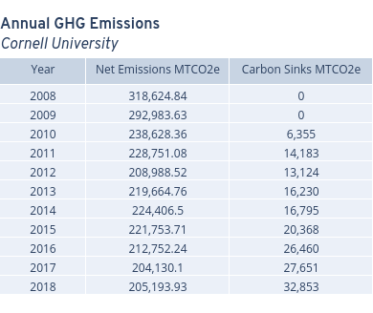
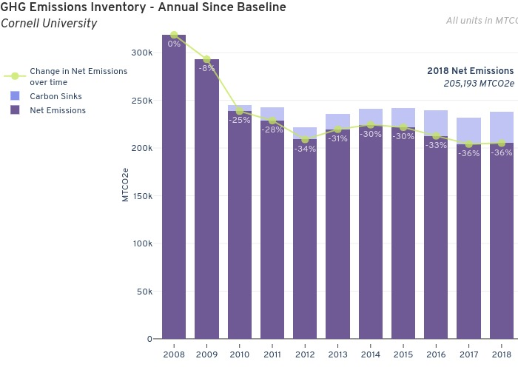

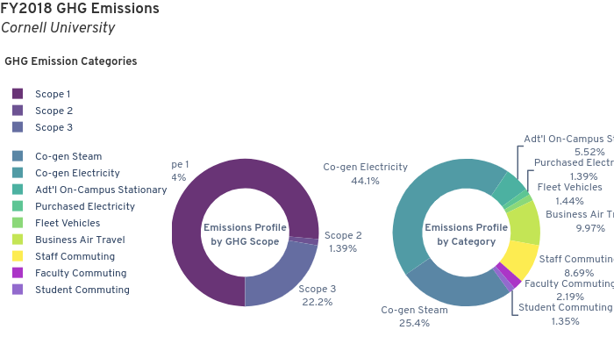

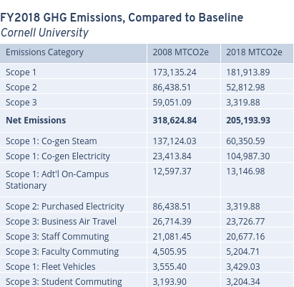

Energy

Energy Conservation
Cornell University’s Energy Conservation Initiative (ECI) is a critical component of the Climate Action Plan. Since 2000, ECI projects have held campus energy use flat despite a 20% growth in square footage connected to campus utilities, thereby reducing the need for procuring renewable energy supply and infrastructure maintenance.

Our Progress
- Projects implemented in FY19 are expected to save $1.2 million in energy costs, with $25 million cumulatively saved since 2008
- Invested more than $40 million since 2008 with an average payback period of 5.8 years
- Reduced Cornell’s carbon emissions from on-campus combustion by more than 17,000 tons annually since 2008 from ECI projects, for an estimated total 65,000 total tons removed from our carbon footprint
- Saved $80,000 in energy costs during the annual winter shutdown
- Received NYSERDA funding to launch use of GRITS – a powerful online platform designed for higher ed planning, tracking, and sharing of energy, financial, and carbon project data
- Saved 24,000,000 kilowatt hours of electricity consumption, the equivalent of 2,677 homes, since 2008

Renewable Energy
Cornell’s carbon neutrality goal includes meeting the Ithaca campus energy needs with 100% renewable energy. In FY19, renewable energy provided 0% of our heating, 98% of cooling, and 10% of electricity needs.
0%
10%
98%

Our Progress
- Leader in the creation and operation of the NY Higher Education Large Scale Renewable Energy consortium which includes 20 other NY SUNY and private campuses. Exploring opportunity to achieve 100% renewable electricity for the Ithaca and Geneva campuses via power purchase agreements leveraging the aggregate purchasing power of the consortium.
- Lake Source Cooling supplies cooling needs using 85% less electricity than traditional means.
- 5 operating regional solar farms offset 10% of annual campus electricity needs
- Construction of 18 MW Cascadilla Community Solar Farm (equivalent to another 10% of campus electricity use) is complete, awaiting interconnection to the local utility distribution grid
- Solar portfolio includes community solar, rooftop, and regional arrays accessible to faculty and students
- Research on solar sites on co-location of sheep (agricultural use) with pollinator supporting vegetation and soil carbon sequestration; and impacts on site hydrology, and small mammal predation
- Sheep mowing crews (in lieu of traditional motorized equipment) manage vegetation at all solar farm sites to prevent shading

Living Laboratory

Teaching and Research
Faculty across disciplines are engaged in teaching and researching sustainability and climate change solutions. The increase in courses reflects improved tagging such as a more encompassing definition of “sustainability” (e.g. social and environmental justice). The figures below show a steady increase in both sustainability courses offered and total numbers of faculty involved in sustainability research since measurement began in 2011.

Our Progress
- 554 faculty are involved in sustainability research
- 683 courses offered on sustainability

Engagement

Faculty & Staff Programs
Faculty and staff worked within college & unit Green Teams to promote sustainability where they work. Cornell Tech launched the newest Green Team in May, and planning is underway for Cornell’s first Green Team Summit in October 2019.

Staff participated in sustainability trainings through the Sustainability Management Academy, Staff Development Day, and customized trainings for individual departments, and continue to be recognized through the Staff Sustainability Champions awards and Cornell University Partners in Sustainability Awards (CUPSA).

Student Programs
Students are encouraged to engage in sustainability from the moment they arrive on campus through orientation events, community meetings, and volunteer opportunities.

- The Residential Compost Program launched in Fall 2018 with 45 trained Compost Managers (student volunteers), who composted over 10,000 lbs of food scraps and napkins during the year from 23 residential buildings on campus.
- Hundreds of students are actively engaged in 40+ sustainability student organizations, many of which collaborate with faculty and staff to create sustainable change on campus.
- SNRC’s TerraCycling initiative is expanding to all residential communities in 2019 in partnership with the Residential Sustainability Leaders program.
- Student internships within the Campus Sustainability Office continue to enable students to develop their professional skills while implementing critical initiatives for the campus community.
- The second annual Golden Gorge Awards recognized students, sustainability clubs, and graduating seniors for their dedication, work, and achievements throughout the year.

Innovation Highlights
Recent innovations on our campus from across departments and initiatives.

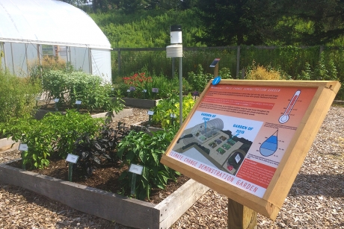
Cornell Botanic Garden: Climate Change
Teaching Garden
1: The entrance of the Climate Change Demonstration Garden, located at Pounder Garden at the Cornell Botanic Garden.
This interactive campus garden demonstrates the impact of climate change on plant growth in New York. Designed by students and installed as part of a living laboratory project.
Climate Change Garden offers a lens into the future
Cornell Chronicle June 8, 2017

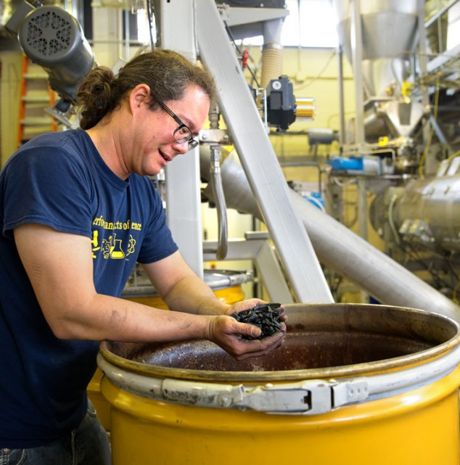
Pyrolysis Kiln
2: Technician Akio Enders examines biochar after it is removed from the new pyrolysis kiln. Photo by Jason Koski/University Photography.
The largest of its kind at any US University, the kiln creates earth-friendly biochar which boosts fertility of soil and will be used operationally and for research advancements.
Trash to treasure: Cornell’s pyrolysis kiln opens
Cornell Chronicle May 17, 2018

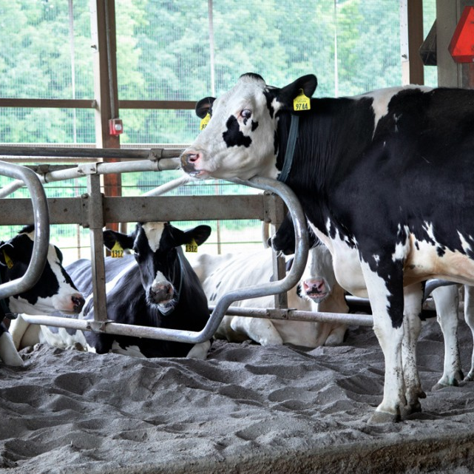
Poop-to-Power Cow Manure Reclamation System
3: Cows relax in the sandy stalls of the College of Veterinary Medicine's Teaching Dairy Barn. Photo by Jason Koski/University Photography
The College of Veterinary Medicine solved a challenging cow waste reclamation issue and is successfully capturing liquid waste for energy production through the Ithaca Area Wastewater Treatment Facility.
Dairy barn implements poop-to-power system
Cornell Chronicle July 10, 2018

Where is the Human in Climate Change? Podcast Series
4: Podcast icon. The podcast is produced by Humanities, in the College of Arts & Sciences.
A global, weekly podcast and essay series focused on the latest thinking from across the disciplines about the relationship between humans and the environment.
New podcast explores ‘Where Is the Human in Climate Change?’
Cornell Chronicle April 17, 2018

Other Metrics

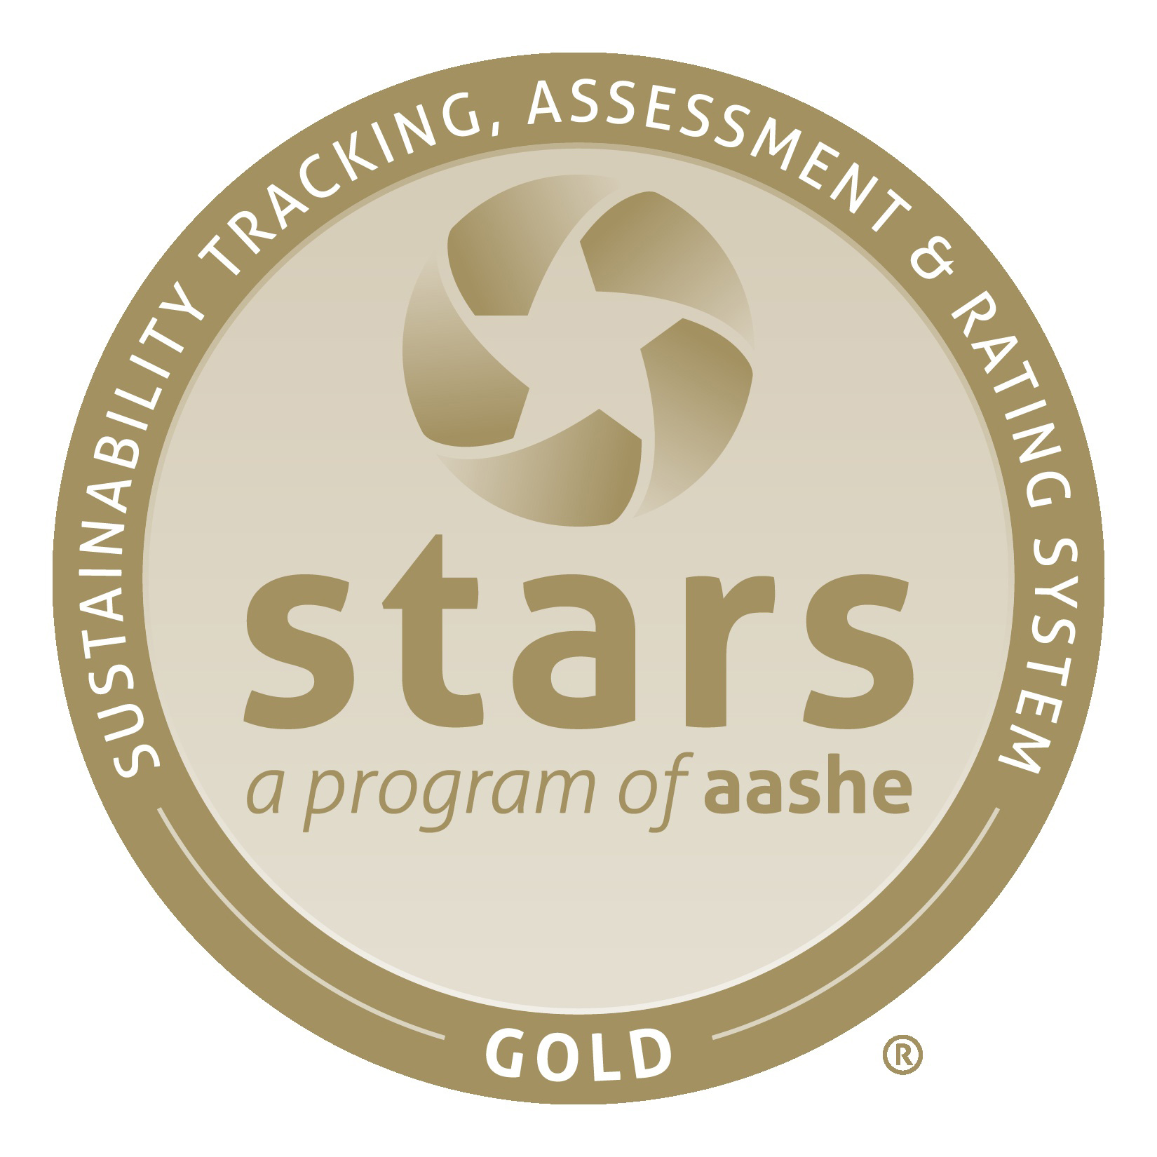
AASHE STARS®
The Sustainability Tracking, Assessment & Rating System™ (STARS®) is a transparent, self-reporting framework for colleges and universities to measure their sustainability performance and includes 1,000s of data points not included in this report.

Waste
Cornell diverts 67.78% of our overall waste from the landfill. This year, the University reclaimed an additional 27.26 tons of materials for reuse, such as office supplies and furniture during remodel and construction. Dump & Run is Cornell’s annual move-out waste program, which reclaims 30+ tons of material from the landfill in addition to the numbers listed above. The new Campus Waste Map shows locations on campus where Cornell recycles, composts, and provides disposal for other types of waste like electronics and medication.

Food
Currently Cornell purchases 90% of dairy needs for the campus from local sources, including our own Cornell Farm Services. Cornell Agricultural Experiment Station Farms provide 100% of the potatoes, winter squash and corn in season for Dining services, and 27% of total fresh produce food expenditures are grown and/or processed within 250 miles of Cornell University or are third-party sustainably certified. The local beef program was reduced to using local beef burgers in two large retail units.

Student Educators
The Campus Sustainability Office launched the Residential Sustainability Leaders (RSL) program. RSLs work in collaboration with the Campus Sustainability Office, Residential Life, and West Campus House System to promote sustainable behaviors, identify issues and implement real solutions within residential communities, and build a culture of sustainability across campus.

Browse our full report
2019 AASHE STARS 1.2 Report, Cornell University

